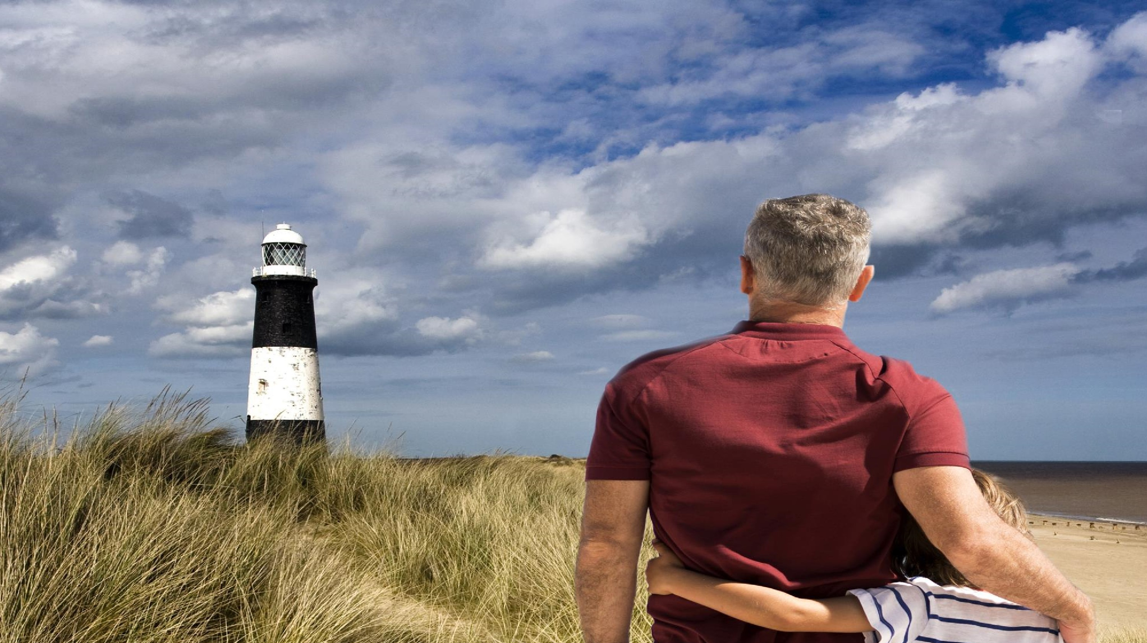
Overview of
the proposals
Scotland to England Green Link 2
April 2021

Meet the team
Mark Williams,
Senior Project
Manager
David Ritchie
Consents Lead
Emma Bennett
External Affairs
Officer
Thomas Hall
Project Community
Relations Team
National Grid | Scotland to England Green Link Peterhead to Drax | April 2021 2

Agenda

- About National Grid

- Need for network reinforcement

- Our proposals

- Where we are now – consultation

- Detailed route fly through

| Scotland to England Green Link Peterhead to Drax | April 2021
01
About National
Grid

Bringing energy to life
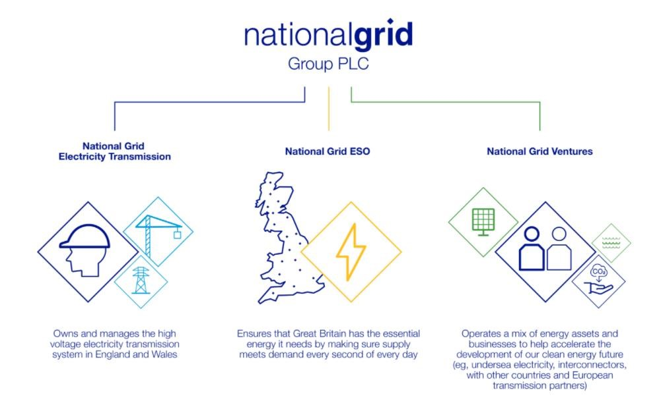
National Grid operate at the heart of the energy system, connecting millions of people safely, reliably and efficiently to the energy they use every day.
We are working to build a cleaner, fairer and more affordable energy system that serves everyone – powering the future of our homes, transport and industry.
| Scotland to England Green Link Peterhead to Drax | April 2021

Moving towards net zero
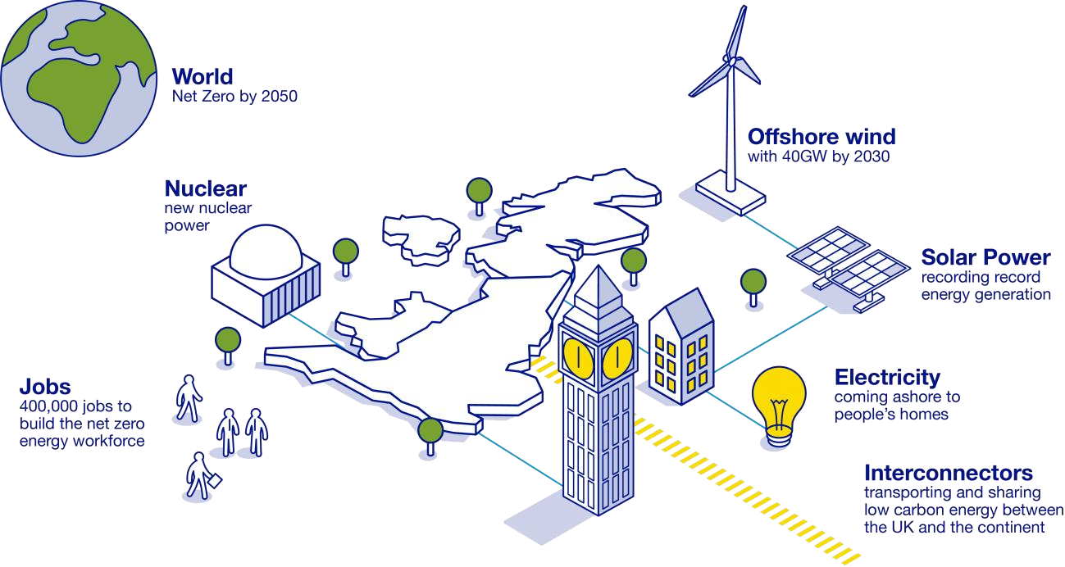
The UK has a world-leading target to tackle climate change, which is to achieve net zero by 2050.
We are already making progress towards this goal 2020 was the greenest year on record for our electricity system.
But more needs to be done.
National Grid | Scotland to England Green Link Peterhead to Drax | April 2021 6
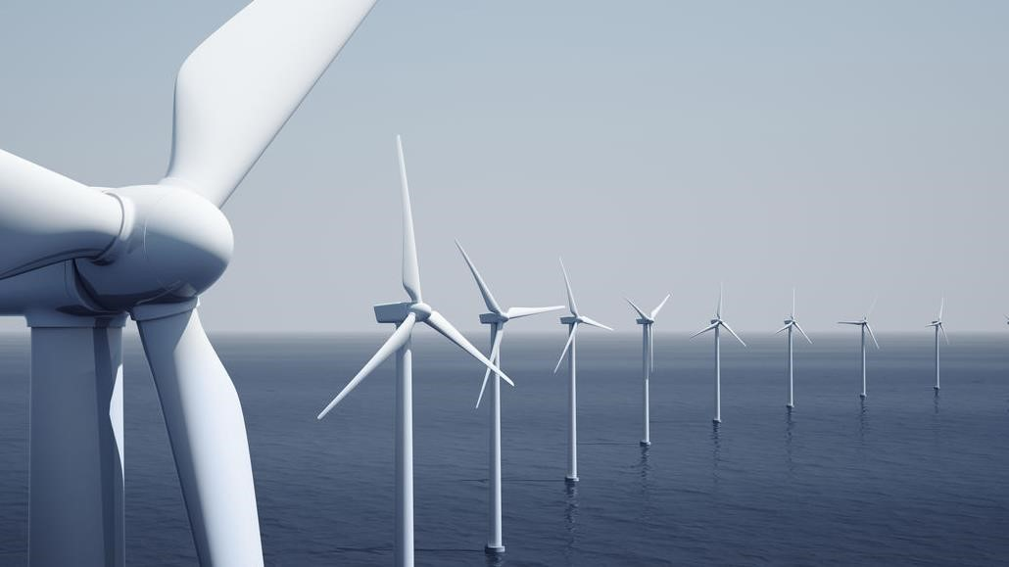
We believe by acting now, the UK can become the
world’s first major clean economy, with net zero
carbon emissions by 2050, creating growth and
jobs for communities across Britain.
UK has l
argest operating offshore wind capacity
in the world
–
8.5
GW with a further 1.9GW under
construction.
Offshore Wind Sector Deal, the Prime Minister’s Ten Point
Plan & Energy White Paper
–
40
GW by 2030 ambition.
Committee for Climate Change
–
expect electricity demand
to double over next 30 years
–
6
th Carbon Budget
–
at
least 100
GW of offshore wind required by 2050
A cleaner, greener future…
02
Need for network
reinforcement
When new sources of electricity seek to
connect to the network, National Grid ESO
must offer terms to connect these sources
to the system.
Under the Electricity Act 1989, transmission
network proposals must be developed in
a manner that is efficient, co
-
ordinated
and economical, whilst also having regard
to the desirability of preserving amenity.
When the development being connected is
offshore, the offshore aspects need to be
considered too.
Our role and obligations

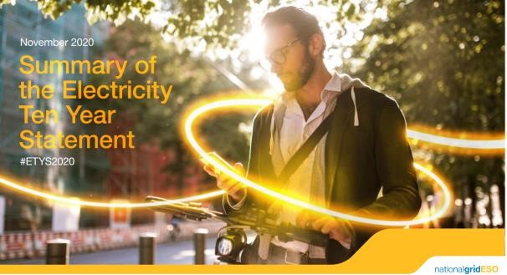
Our role and obligations
10
To identify future network requirements, National Grid ESO, the System Operator, leads an annual review cycle:
- Future Energy Scenarios are discussed with stakeholders and then published each summer
- These then inform the analysis in the Electricity Ten Year Statement of transmission network requirements for the next decade – this is published each autumn
- Then, the Network Options Assessment in the spring recommends which projects proceed to meet future network requirements
National Grid | Scotland to England Green Link Peterhead to Drax | April 2021

Meeting the UK’s green energy ambitions
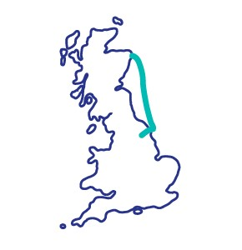
- The Government has a net-zero in all greenhouse gases target in place for 2045 in Scotland and 2050 in England and Wales. • By 2030 the Government’s target is for 40GW of offshore wind to be delivered – enough to power every home in the UK.
- To help deliver green energy to homes and businesses across the UK, we need to increase the capability of our network between Scotland and England
- To do this, we are proposing the construction of two new High Voltage Direct Current (HVDC) links which will operate as electricity superhighways from Scotland to England.
- These links will be called the Scotland to
England Green Links or SEGL1 and SEGL2.
03
Our proposals

Our proposal
- We are proposing the construction of a 2GW
HVDC link called SEGL2, which will run from Peterhead in Aberdeenshire to Drax in North Yorkshire.
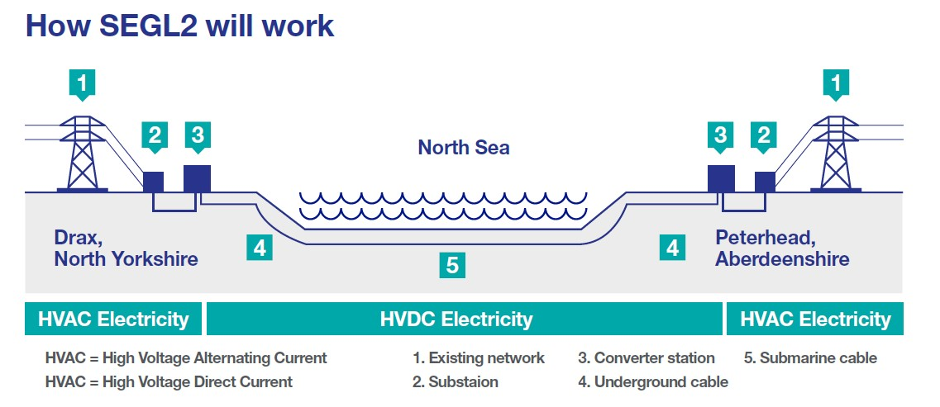
- This link will carry enough power for two million homes.
- We are also proposing to build a new convertor station and install underground cables from our landfall point at Wilsthorpe to Drax.
- The proposed locations for the new converter station and cable route have been selected after extensive research and planning.

Subsea offshore cable laying
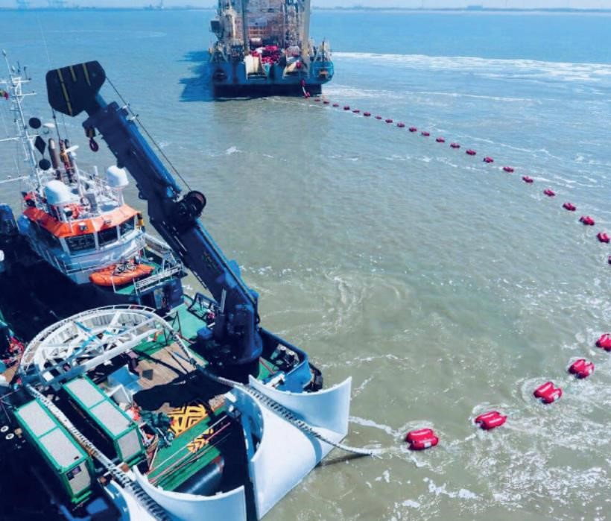
- The majority of the route will be offshore subsea cables, 440km.
- We undertake extensive maritime surveys to ensure that we cause minimal environment impact when laying subsea cables.
- This image is from another project, however it is indicative of the process we will use to lay the subsea cables.

Underground onshore cable laying
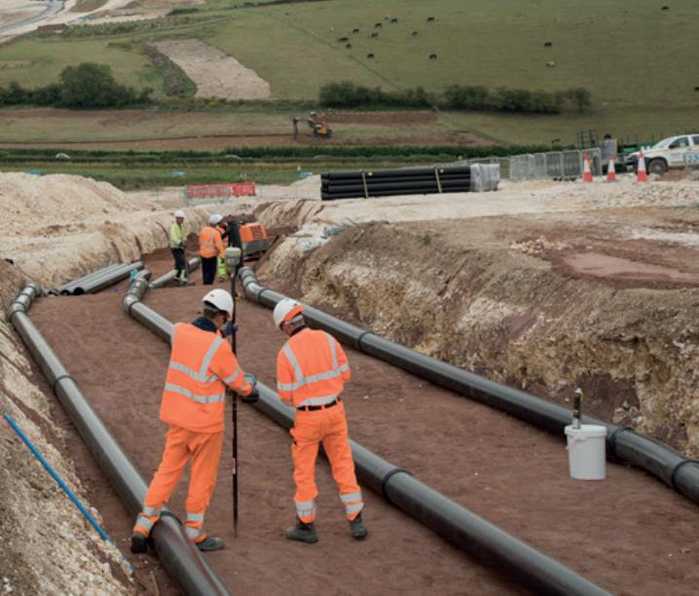
- In England, there will be 65km of cabling underground onshore.
- Cables will be installed 1.5m underground.
- National Grid has a policy of Biodiversity Net Gain +10, which means we always seek to leave the area in a better biodiversity position than it was before.
- Agricultural land in which cables are buried generally ‘recovers’ within 6 months
- This image is from another project, however it is indicative of the process we will use to lay the onshore cables.
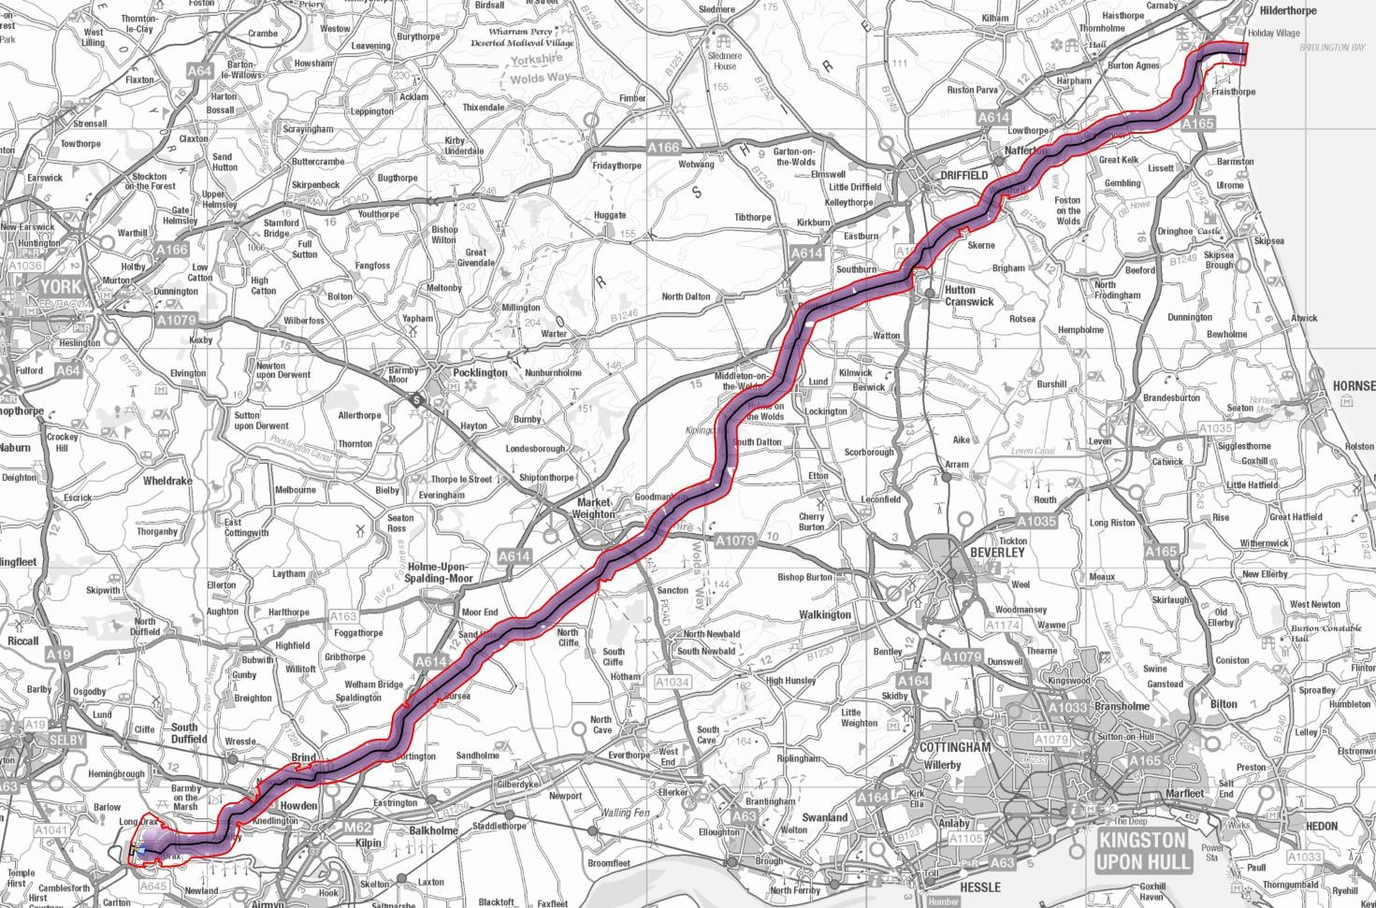
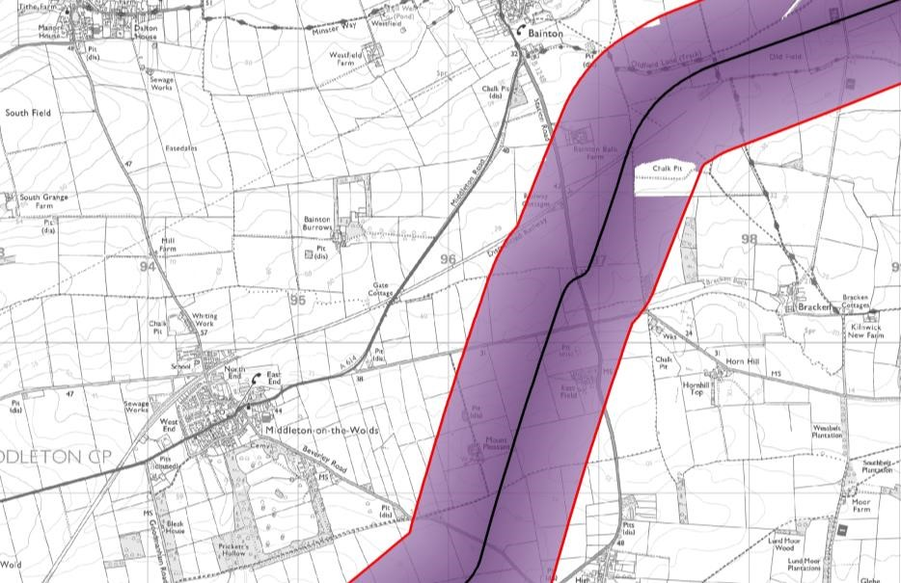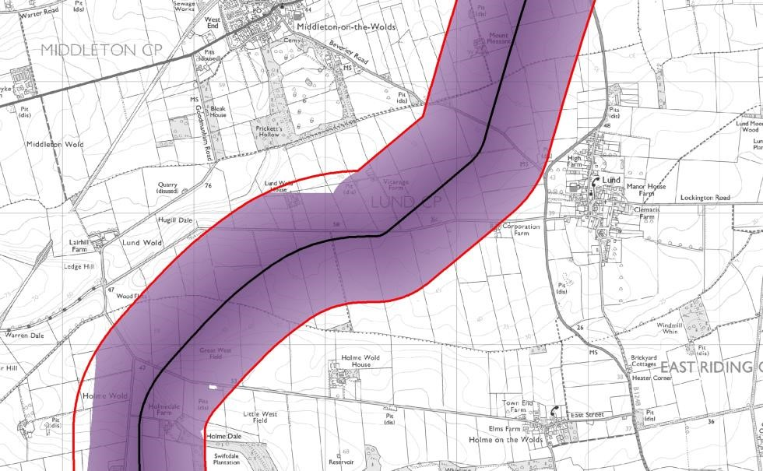
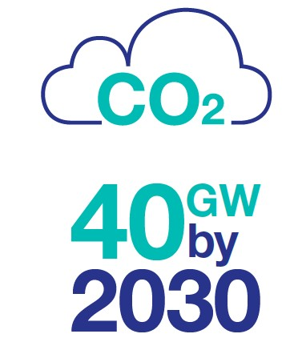
Why Drax?
- Before recommending a location for the new converter station and proposed route, many factors were carefully considered including cost, benefit to the network, minimising infrastructure and impact on people, places and the environment.
- Drax already has a National Grid substation which is an access point to the UK electrical grid.
- Connecting SEGL2 to the existing network here provides the capability needed to deliver cleaner, greener energy to the rest of the country in the most optimum way.

Why Drax - continued
The new converter station and existing substation are critical components of our project.
- Our converter station will house the technology to enable clean electricity to be transmitted through the 505km cable.
- Currently finalising the design of the converter station, but we expect it to a have a footprint of approx. 170 x 220 metres and be up to 30 metres in height.
- Substations are critical for controlling the voltage of electricity between the network and peoples’ homes and businesses.
- We will connect the new converter station to the existing substation by constructing underground cables.
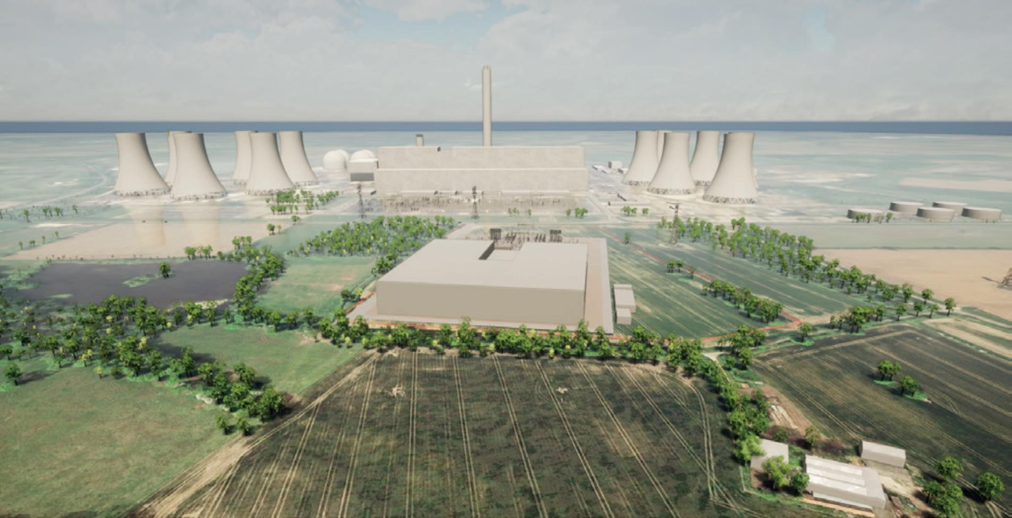
An indicative image of our Drax converter station

04
Where we are now
–
Consultation

Where we are now - consultation
We are currently holding a public consultation to seek views on our early proposals for SEGL2. We have set out the vision behind our proposals, the key elements of the project and how the community can share their feedback.
- Current consultation runs from 29 March – 23 April.
- We will be applying for planning permission in Early 2022, but before we do, there will be another opportunity for people to hear about our plans at public information events.
- Our consultation for SEGL1 will launch shortly.
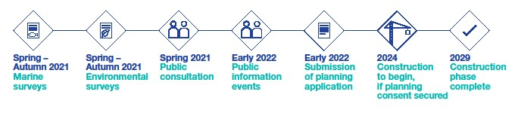
Scotland to England Green Link Peterhead to Drax | April 2021

Supporting the communities where we work

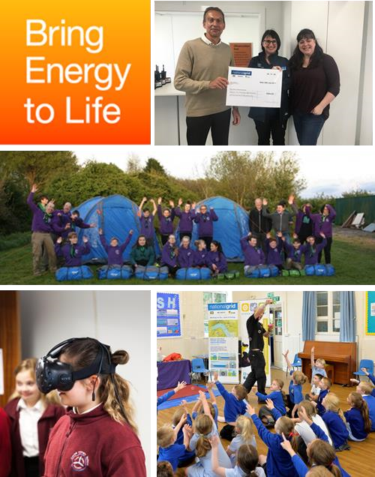
Our Community Grant Programme
Supporting charitable & not-for-profit community organisations in areas we are working with grants for social, economic and environmental initiatives – how to apply & find out more here

STEM initiatives
Encouraging the next generation to get inspired about science, technology, engineering & maths – e.g. funding Science Made Simple sessions for local primary schools
Skills development
Supporting the long term unemployed with skills development training

Supporting local charities
Donations to local good causes through our construction site observation card system
| Scotland to England Green Link Peterhead to Drax | April 2021

Key links and contact details

Public consultation website
https://www.nationalgrid.com/uk/electricity-transmission/network-andinfrastructure/segl2 Digital exhibition
https://www.nationalgrid.com/uk/electricity-transmission/network-andinfrastructure/segl2/digital-exhibition

Resident and stakeholder feedback form
https://www.nationalgrid.com/uk/electricity-transmission/network-andinfrastructure/segl2/feedback

Contact details for our project team
Telephone: 0808 196 8407 Email: info@segl2.nationalgrid.com
| Scotland to England Green Link Peterhead to Drax | April 2021

